1. DX = A + B + C

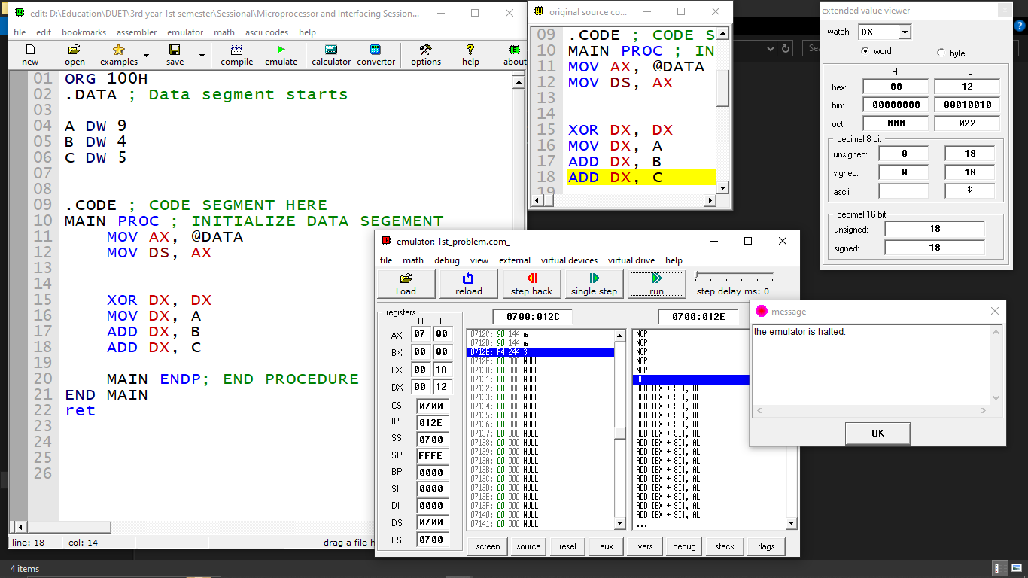

1. BX = A + D - B - C

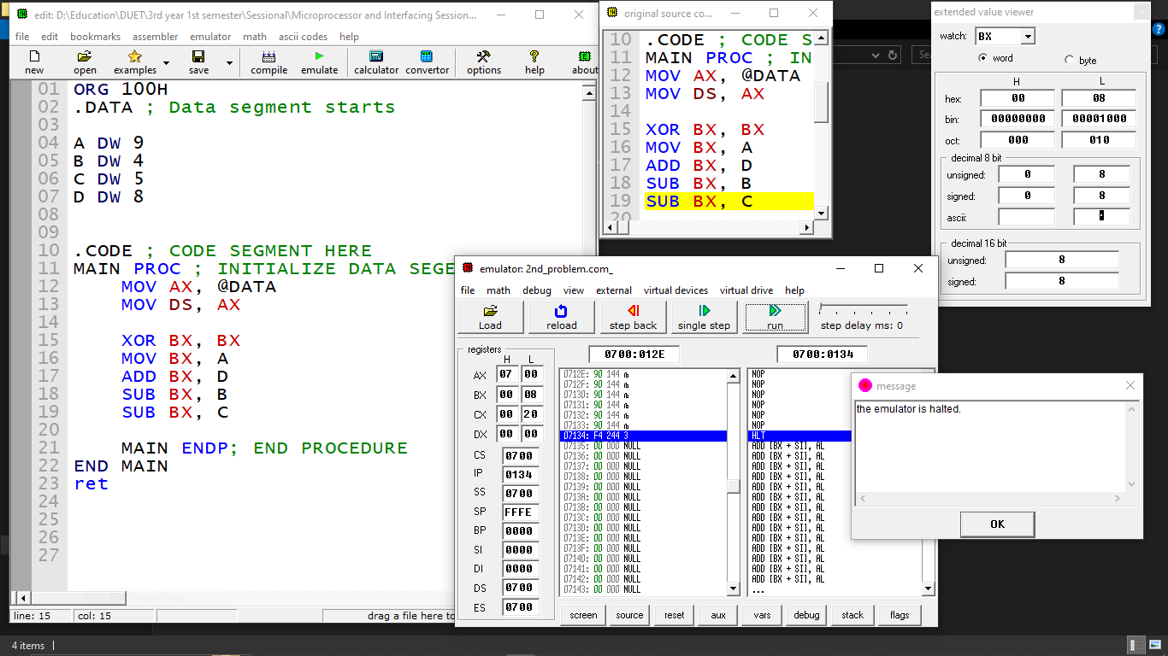

1. Initialize the BX to 5H. Evaluate BX - E + 10H and Store Result into AX.

